*Save the Earth Now* : How to Help Fight Climate Change

Aleena Kazmi

Save The Children Association

ITE 152

Professor Ansari

June 26, 2024

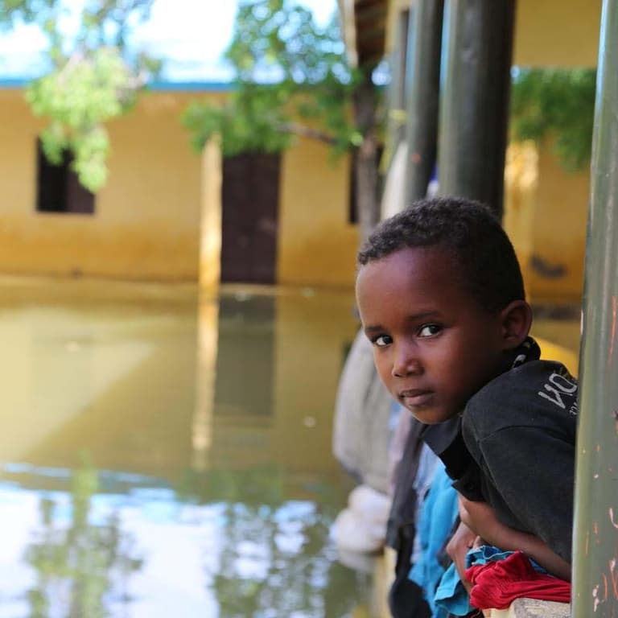

*“While climate change affects everyone, those who have contributed the least to the crisis, children, those in poverty, and future generations, are the most affectd.”* Save The Children, Inc.

Major Statistics On The Effects of Global Warming Towards Children:

* By 2040, it is estimated that **one in four children will be living in areas with extreme water shortages**.
* Almost **160 million children are exposed to increasingly severe and  prolonged**[**droughts**](https://www.savethechildren.org/us/charity-stories/drought).
* **The education of around 38 million children is disrupted each year** by the climate crisis.
* The climate crisis is forcing families to migrate. By 2050, **there could be 143 million more migrants** due to the climate crisis.

How to Help Fight Global Warming:

* **TAKE A WALK** leave your car at home, try to walk or cycle as much as you can! It’s a great and healthy choice of transportation. If you have to drive, get an electric car.
* **LESSEN YOUR POWER** switch to a zero-carbon, get a renewable energy provider, or install solar panels on your roof
* **PLANT TREES** every year, approximately 12 million forests are destroyed and we take part in it through our abuse of land.

Reference(s):

Save The Children, Inc. . "Climate Change Is a Grave Threat to Children’s Survival." (2024). [Effects of Climate Change on Future Generations | Save the Children](https://www.savethechildren.org/us/what-we-do/emergency-response/climate-change?cid=Paid_Search:Bing_Grant:TT_Climate:Nonbrand:090622&ds_e=MICROSOFT&s_kwcid=AL!9048!10!79646079034459!79646464267005&ds_k=climate+change&gclid=b23ef3415ef819fa19f6953d7160013b&gclsrc=3p.ds&msclkid=b23ef3415ef819fa19f6953d7160013b)

(UN Environment Programme) [10 ways you can help fight the climate crisis (unep.org)](https://www.unep.org/news-and-stories/story/10-ways-you-can-help-fight-climate-crisis)